<최종 원고 템플렛; 언어는 영어, 한국어 중 자유롭게 선택하여 작성하실 수 있습니다>
The Research Papers Published
in the Journal of the Ergonomics Society of Korea: A Trend Analysis of Ergonomics Studies in Korea
Dhong Ha Lee¹, Gildong Hong², A.B. Park²
¹Department of Industrial Engineering, The University of Suwon, Suwon, 445‐743
²ABC Team, ABC Research Institute, Daejeon, 000‐111
ABSTRACT
Objective: The aim of this study is to investigate the attributing factors influencing major research areas of the papers published in the journal of Ergonomics Society of Korea (JESK). Background: Ergonomics has a wide range of research areas. Diversity of research topic is one of the major strong points of this discipline especially in the era of fusion. Dominant areas among the diversity changed from time to time. It is interesting to study the attributing factors of the dominant areas. Method: During the past three decades JESK has published 649 articles. We reviewed these papers and sorted them into the detailed research fields of ergonomics; (1) a grouping of the technical group (TG) s of the Human Factors and Ergonomics Society (HFES), (2) an editing grouping of the journal of Ergonomics Abstracts and (3) a grouping of the TGs of the Ergonomics Society of Korea (ESK). We also listed major events which might affect the publication trend. Results: Anthropometry was the most dominant area all the time. Health and safety area has been steadily increasing in publication amount. Conclusion: Government research funding was the main attributing factor determining the publication trend of the JESK. Application: The results of the publishing trend analysis might help to determine the editing policy of the JESK.
Keywords: Trend analysis, Publication, Research papers, Journal of the Ergonomics Society of Korea

1. Introduction
본문은 영문이나 국문을 모두 사용할 수 있다. 그러나 제목, 저자명, 저자소속, 구조화된 초록, 주제어, 장절 제목 (Subheadings), 표, 그림, 감사의 글 (Acknowledgements), 참고문헌은 영문으로 작성하여야 한다. 국문으로 작성된 참고문헌은 영문으로 번역되어야 한다. 이와 같은 서지정보 (Bibliographic information)와 검색정보들은 각종 문헌색인데이터베이스에 등재되어 전세계적으로 인용되어야 하기 때문이다.
Since the JESK one of the most active centrum of the Korean ergonomists' idea was launched, it has grown quantitatively as well as qualitatively in publication activities. Not only the number but also the research fields have become diversified in the papers published in the journal.
Zavod and Hitt (2000) examined the content of each article published in the journal Human Factors during 1988~1997 for subsequent classification within TGs of HFES.
Hitt (2000) reviewed the publishing trends in the HFES proceedings of the year 1988~1997. He also used 20 TGs from which each presentation paper is assigned as a classification method.
Lee (2000) grouped the ergonomics papers published in the journals and proceedings into (1) anthropometry and physical and physiological characteristics of human, (2) human performance, (3) industrial design, (4) manual materials handling and safety, (5) human computer interactions, (6) sensibility engineering, (7) aviation safety, (8) design of medical devices, and (9) aging.

2. Method
JESK published 649 articles during the year 1982 to 2009. The author examined each article and coded along 5 dimensions, which included (Size Korea Home Page, 2011):
(1) Year of publication: 1982~2009,
(2) Period of publication: 1980s (1982~1989), 1990s (1990 ~1999), and 2000s (2000~2009) with historical events occurred during each period,
(3) Classification method 1: TGs of the HFES (Table 1)
3. Results
Table 1. Three classification methods by which articles were assigned
Classification method 1 | Classification method 2 | Classification method 3
Accidents, Safety, and Human Error | Display and Control Design | Biomechanics
Aerospace Systems | Environment | Cognitive science
Aging | General Ergonomics | Design ergonomics
Some descriptive statistics along the above 5 dimensions reflected the change of the ergonomics research activities of Korea during the past three decades. The coefficient of variation can be expressed by the equation (1).

CV = (SD/mean) × 100(%) (1)
3.1 Year of publication
In the first year the JESK published 12 articles. In 2009 the JESK published 47 articles, showing annual average growth rate of 11 percent (Figure 1). Table 2 shows that different time interval was significantly higher than normal situation (χ²=17.22, p<0.05), (F(8, 16) = 3.71, p = 0.012).

3.2 Period of publication
We called the period of 1980s as the infant period of ergonomics (Lee et al., 2003). The ESK was established in 1982 by K. Park and his colleagues. Researchers working with industrial engineering, garments, or

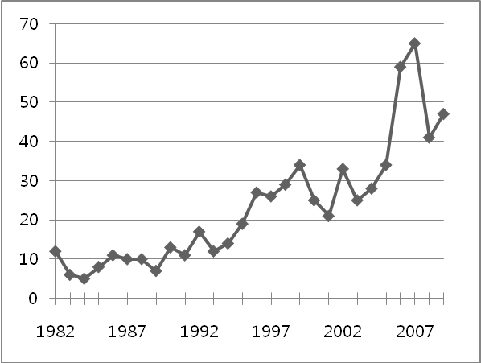

Figure 1. The annual numbers of papers published in the JESK

Table 2. The result of comparison of ANS response between
baseline and happiness condition (N=217)
 | Baseline | Happiness | t
HR | 81.3±10.7 | 82.9±11.6 | 3.2**
SD_RRI | 35.7±15.4 | 37.5±13.7 | 1.5
LF | 0.4±0.2 | 0.4±0.1 | 3.0**
HF | 0.6±0.2 | 0.6±0.1 | 3.0**
HRV | 0.9±0.7 | 0.7±0.5 | 3.5**
BVP | 0.2±0.1 | 0.1±0.1 | 11.3***
Resp_R | 3.9±1.2 | 3.3±0.6 | 8.5***
Resp_A | 4.4±3.9 | 4.5±3.8 | 1.0
Resp_Rsd | 0.5±0.4 | 0.6±0.4 | 3.4**
Resp_Asd | 0.6±0.7 | 1.0±0.9 | 6.7***
SCL | 0.2±0.2 | 0.3±0.2 | 6.4***
SCR | 0.1±0.3 | 0.9±0.8 | 13.3***
Mean SKT | 31.9±2.6 | 31.8±2.5 | 8.1***
M ± SD *p<.05, **p<.01, ***p<.001

4. Conclusion
One interesting and remarkable point is a publication trend in health and safety area. As mentioned earlier the rank of this area has steadily risen all over the periods (Figure 3 to 8). The researchers majoring heath science area such as rehabilitation medicine have joined the ESK and actively published papers on work physiology and human characteristics.
Acknowledgements
This work was funded by grants from Korean Federation of Science and Technology Societies (Grant-#KFSTS0000000).
References
Furness, T.A. and Kocian, D.F., "Putting Humans into Virtual Space", Proceedings of the 16th Conference on Aerospace Simulation, 2 (pp. 48-52), San Diego. CA. 1986.
Karhu, O., Kansi, P. and Kuorinka, I., Correcting working postures in industry: a practical method for analysis, Applied Ergonomics, 8(4), 199-201, 1977.
Wiliges, R.C., Design of Human-Computer Dialogues. In G. Salvendy (Ed), Human-Computer Interaction, Elsevier, Amsterdam, 125-153, 1984.
Woodson, W.E., Tillman, P. and Tillman, B., Human Factors Design Handbook, 2nd ed., McGraw-Hill, 1992.
Author name, Title of contents, Website name, URL (retrieved date).
Dove, R., Lady Freedom among Us, The Electronic Text Center, http://etext.lib.virginia.edu/subjects/afam.html (retrieved June 19, 1998).
Kachru, B.B., Norms, models and identities, The Language Teacher Online, 20(10), 1996, http://jalt-publications.org/tlt/files/96/oct/index.html (retrieved October 25, 2001).
Polymer Society of Korea Home page, http://www.polymer.or.kr (retrieved July 14, 2003).
Size Korea Home Page, http://sizekorea.kats.go.kr (retrieved December 1, 2011).
University of Georgia, Points of Pride, University of Georgia, http://www.uga.edu/profile/pride.html (retrieved October 21, 2009).
Author listings
Dhong Ha Lee: dhonghal@suwon.ac.kr
Highest degree: PhD, Department of Industrial Engineering, KAIST
Position title: Professor, Department of Industrial Engineering, the University of Suwon
Areas of interest: Human Factors in Nuclear Power Plant, Risk Management, HCI

Gildong Hong: gildonghong@ergonomics.ac.kr
Highest degree: PhD, Department of Industrial Engineering, KAIST
Position title: Researcher, ABC team, ABC Research Institute
Areas of interest: Human Factors in Mobile Design, Safety Management

A.B. Park: abpark@ergonomics.ac.kr
Highest degree: PhD, Department of Industrial Engineering, KAIST
Position title: Senior Researcher, ABC team, ABC Research Institute
Areas of interest: Human Factors in General Area

